* LED WITH PUSHBUTTON :-

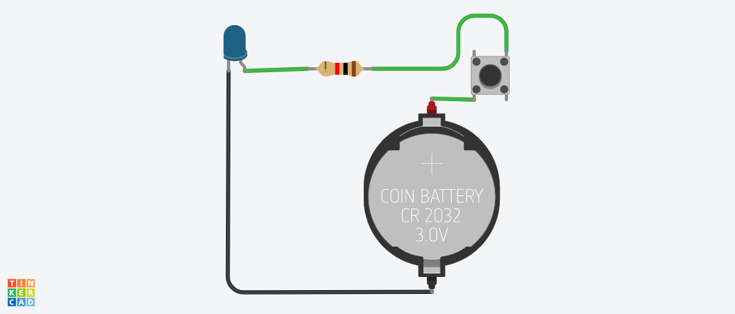

**Circuit diagram**

* **Description :-**

This project is for LED on & off by pushbutton. A pushbutton is one kind of switch, a mechanical device that **connects or breaks a circuit**.

* **Application :-**

Home appliances, Light or Bulb, Torch etc.

* **Working :-**

The one leg of Push button is connected to 3Vsupply and the other one is connected with LED via the resistor, as shown in circuit diagram.

Initially, Push Button does not allow the current to flow through it, but when it is pressed it completes the circuit and LED will start to glow.

* **Components :-**

1. Led
2. Pushbutton Switch
3. Resistor
4. 3v Coin Battery CR2032